1. Profile 总则
1.1大型离心鼓风机（压缩机）属高速重载类旋转机械，对机组本身和系统配套装备均有很高的要求，除本说明书明确的要素外对未涵盖的内容针对不同的个体还需做具体的规范。
Large-scale centrifugal blower (compressor) belongs to a kind of high speed heavy load rotary machine. It has higher requirement for both machine body and matching equipment of the system. Besides clear factors required in the specification, special standard shall be set for individuals, which is not covered in it.
1.2 本产品说明书为离心鼓风机产品的通用说明书。内容包括有关离心鼓风机设备的安装、操作和维护方面的基本资料。但并不包括设备变动的所有细节，也不具有鼓风机安装、操作和维护方面所遇到的各种可能发生的意外情节。有关鼓风机系统配套设备的详细规格和参数参见有关产品的专用说明书。
This catalogue is a general products specification and covers basic information on installation, performance and maintenance of centrifugal blowers. But neither all of the details regarding equipment variation, no probable unexpected situation might occurred on installation, performance and maintenance of blowers is covered. Refer to other related specified products catalogue for detailed specifications and parameters of matching equipment.
本产品说明书所叙述的安装和操作方面的技术要求，不能作为买方的安装和操作技术规程。说明书仅将该产品在安装和操作时，应该注意和必须保证的技术要求给予提示，供施工方和买方单位在编制安装与操作规程时参考。所编制的安装操作规程，还应符合国家标准标及相关技术文件的要求。
Technical requirement regarding installation and performance described in this catalogue is not as a technical regulation for installation and performance of the buyer. It is only as a note of technical requirement being noted and ensured in installation and operation, and a reference for manufacturer and the Buyer to compile installation / performance regulation. The compiled installation / performance regulation shall be in accordance with the requirement of national standard and relative technical documents.
1.3 本产品说明书主要叙述鼓风机本体部分。辅机及配套的润滑油站、增速器、管网系统及电自控装置，请详见相应产品所附带的有关说明书。
This catalogue describes mainly the body of blower. Refer to relative specifications attached hereby for details on auxiliaries and matched lubricate station, speed increaser, pipeline network system and electric auto-control device.
1.4 鼓风机所输送的气体必须干净，含尘量应≤10毫克／米³，含尘的颗粒当量直径应≤5～8µm，若含尘量达不到上述要求，应对进入鼓风机前的气体进行除尘处理，以保证鼓风机安全平稳的运转和较长的使用寿命。
Gas sent to the blower shall be clean with dust content ≤10mg/m³, equivalent diameter of dust granule shall be ≤5～8µm. If the above mentioned requirement is not reached, dedusting shall be conducted for gas before entering into the blower to ensure safety and stable running and longer usage life of the blower.
1.5 在鼓风机安装时所需的起吊、测量工具及调试的应满足设备的精度要求。
Lifting, measuring tools used in blower installation and debugging shall satisfy with the accuracy request of equipment.
1.6 鼓风机组所需的测量仪表，卖方仅成套供应一次仪表元件，如各种规格的压力表、流量测量元件、温度计、轴位移及轴振动测量探头等。买方需要集中控制时，则二次仪表，连锁用继电器及控制屏均由买方或设计院设计自行成套或根据技术协议要求执行。
For measuring instrument needed by blower unit, the Seller supply only one time of instrument element together with a complete set of equipment such as every type of pressure gauge, flow measurement element, thermometer, measuring probes for axial displacement and shaft vibration, etc. If the Buyer needs centralized control, the secondary instrument, relays for linkage and control panel shall be designed as a complete set by the Buyer or designing institute themselves or carry out it according to the technical agreement.
1.7 产品的各种装箱到达用户现场后，应妥善存放在室内严防潮湿。如产品需长期存放其室内的相对湿度应满足机电产品保管条件，并定期（一般不超过6个月）开箱检查箱内的零部件，防锈保护层情况，必要时更换防护油及箱内的防潮剂（胶质二氧化硅）。尤其是鼓风机的转子和增速器的小齿轮每3个月作一次180°旋转，以防止产生永久性变形。
All kinds of products package shall be properly stored indoor and taken strict precautions against moisture when arriving at the site. If it shall be stored for a longer time, relative humidity of the room shall be met with the storage condition requirement for mechanical and electrical products. And open these packages and check rust prevention layer of elements periodically (in general, less than 6 months); if it is needed, change preservative oil and moisture proof agent (colloid silicon dioxide). Small gear used for the blower rotor and speed-up gear shall be rotated 180° once per three months to prevent it from permanent deformation, especially.
1.8 卖方所提供的设备按国家标准规定，质量保证期是从产品发货之日起18个月内或运行12个月（以两者中先到的期限为准）为限，此间以不发生材料、制造工艺及性能方面的缺陷为质保内容，并对非使用原因出现的故障进行及时的服务。
According to national regulations, the quality assurance date of equipment supplied by the Seller shall be within 18 months from the delivery date or operating for 12 months (the shorter period shall be the deadline). Quality assurance includes no defect occurred on materials, manufacture process and performance within the period, and serve troubles in time, which are not caused by inactive use.
1.9 买方在收到设备后，应先检查所收到设备及包装是否在运输过程中受到损伤。如果发现有任何损伤迹象，应详细记录并立即书面通知卖方和货运单位。
After receiving equipment, the Buyer shall check all of the equipment and package to see if it is damaged during delivery procedure. If there is any damage mark, record it in details and send notice to the Seller and shipping unit in a written message in time.
2. Products Overview 产品概述
2.1 离心鼓风机是用于气体压缩和气体运输的旋转机械，在鼓风机主轴上装有一个或多个离心式叶轮构成转子，当转子由原动机拖动旋转时，旋转的叶轮叶片给气体以作用力，并推动气体流动。然后气体经过叶轮出口处的扩压器扩压（即将气体的一部分速度能转化为压力能）。气体经多级叶轮增压，最后由蜗壳汇集经排气管道流出，将具有一定压力的气体输送到装置中。
Centrifugal blower is a rotary machine used for gas compression and transportation. A rotor is composed by one or more centrifugal impeller. When the rotor is rotating by a prime motor, gas will be forced to flow by rotary impeller blades and will be defused by a diffuser, which is fitted at the outlet of the impeller (that is, change part of gas velocity energy into pressure energy). Gas pressure will be increased by multilevel impellers, finally, it will be gathered by a volute casing and flown out through extract duct, the, the gas with certain pressure will be transferred to the equipment.
离心式鼓风机之所以能提高气体压力是因为气体流经旋转的叶轮时，叶片对气体做功，使气体分子相互靠近并加剧运动的结果。气体在风机中压力形成完全取决于旋叶轮旋转的作用。
The reason to increase gas pressure by the centrifugal blower is: when gas is passing through rotary impeller, blades will do work on gas and force its molecules get closer with each other in intensify movement. Forming in blower, gas pressure is fully depends on the action of impeller rotation.
2.2 离心鼓风机通常采用电机驱动方式，对于大型机组（大流量或高压比）的则多选用汽轮机驱动。由于汽轮机具有调速功能可以最大限度的扩展离心鼓风机的性能范围，从而满足不同气象条件下对流量和压力的要求。在特定条件下还可以实现能源的循环利用，如高炉用离心风机就可以利用高炉煤气烧锅炉驱动汽轮机就可以节约高昂的运行成本，以1080m³高炉为例采用汽轮机驱动时（剔除运行和管理费用）年可以节约电费不低于5000万元。
Generally, centrifugal blower is driven by a motor. Large-scale unit (with large flow rate or high pressure ratio) is driven by turbine. As speed regulation function and utmost extend performance scope of centrifugal blower, turbine can meet with the requirement for flow rate and pressure under different climate condition. Further more, under certain condition energy recycle is realized, such as by using centrifugal blower, BF gas is used to drive turbine to reduce operational cost. For example, adopt turbine drive (except for operational cost and management cost), one set of 1080m³ BF might save electricity fee not less than 50 billion Yuan per year.
大型离心鼓风机一般是根据买方所提供的系统作为设计依据，通常单机压比≤3.7采用单缸3级叶轮结构，当压比≥3.7则采用单缸4级叶轮，如果系统对出口温度有要求或压比≥4.1时就必须增加中间冷却，即称为四级两段；当进口流量≥3600m³/min压比≥4.1则宜采用两缸两段，此时可以保证轴系为刚轴以提高机组的运行质量，同时也有利于中间冷却器的布置。
Generally, a design basis for a large-scale centrifugal blower is in accordance with the system supplied by the Buyer. Regularly, when pressure ratio of single machine is ≤3.7, adopt one-cylinder, 3-level impeller structure; when the pressure ratio is ≥ 3.7, then, one-cylinder, 4-level impeller is adopted. If there is any requirement for outlet temp., or pressure ratio ≥4.1, intermediate cooling shall be added, that is called 4-level, 2-section. When inlet flow rate is ≥3600m³/min, pressure ratio is ≥4.1, then, it is in two -cylinder, 2-section to ensure the shafting is hard to improve operation quality of the unit, also, in the same, it is benefit for the arrangement of the intermediate cooler.
离心鼓风机主机由定子、转子、轴承及联接等部件组成，转子由主轴、叶轮、隔套、平衡盘组成。利用膜片联轴器或齿式联轴器将增速器与鼓风机、增速器与电动机转轴联接成轴系。鼓风机的进气口为矩形，出气口为圆形，通常位于缸体中部，方向均垂直向下，便于安装与检修。鼓风机、电机或汽轮均采用滑动轴承。所配置的润滑油站为双电动油泵互为备用，供鼓风机正常启动、停车供油，高位油箱供油系统事故或突然停电时润滑轴承之用。
The core of a centrifugal blower is composed of stator, rotor, bearing and coupling, etc., while the rotor is composed of main shaft, impeller, spacer, balance drum. Adopt diaphragm coupling or tooth coupling to link speed-up gear and blower, speed-up gear and rotating shaft of the motor into shafting. The inlet of the blower is in rectangle, outlet is round. It is generally located at the middle of cylinder body, all in plummet direction to ease installation and maintenance. Sliding bearing is adopted for blower, motor or turbine. Working and standby alternatively, twin electric oil pump is installed in the lubricate station to supply oil for normally starting and stopping of the blower, lubricating bearing in case of emergency or sudden power cut of the oil supply system of the top petrol tank.
本系列鼓风机的叶轮均采用三元流动空间曲面叶型，其效率比传统的二元叶型高8%以上节能效果显著。叶轮材质选用高强度低合金钢强度等级为85MPa以上，圆周速度一般为控制在280～320m/s，
Three dimensional flowing space curved surface blade profile is used in this series blower impeller with higher energy saving effect, that is, more than 8% efficiency in comparison with traditional two dimensional blade profiles. High tension low alloy steel with strength grade higher than 85MPa is adopted as the material of the impeller blade. The peripheral speed is controlled within 280～320m/s, in general.
对输送重介质气体时圆周速度适当降低,图2-1为离心鼓风机的外观及内部结构示意图。
When transferring heavy medium gas, the peripheral speed shall be reduced adequately. Drawing 2-1 is a structure diagram of the exterior appearance and internal structure of a centrifugal blower.

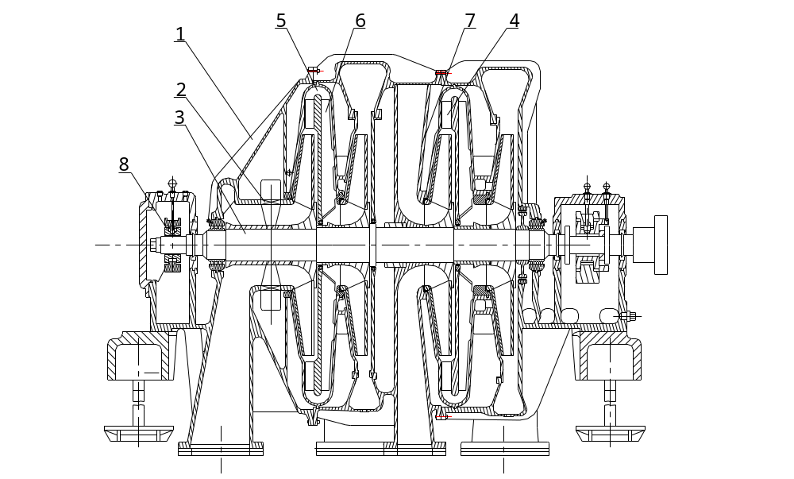
Drawing 2-1 Structure Diagram of a Centrifugal Blower
图2-1离心式鼓风机示意图
1-Shell 2-Inlet pre-rotator 3-Rotor 4-Diffuser 5-Curved conduit
6-Return passage 7-Clapboard 8-Bearing
1-机壳 2-进口预旋器 3-转子 4-扩压器 5-弯道 6-回流器 7-隔板 8-轴承
2.3 Main Performance Parameter (Scope) of Equipment
各设备主要的性能参数（范围）
2.3.1 Centrifugal Blower 鼓风机
2.3.1.1 Manufacturer: Xian Shengtang Blower Co., Ltd.
制造单位：西安胜唐鼓风机有限公司
2.3.1.2 Type: D series (one-cylinder 2-section or Two-cylinder, 2-section with intermediate cooler);
型号：D系列（单缸二段或两缸两段具有中间冷却器型）
2.3.1.3 Inlet volume flow: 进口容积流量：2000～5000m³/min
2.3.1.4 Outlet pressure: 出口压力：200～600kPa
2.3.1.5 Speed of main shaft: 主轴转速：3000～6500r/min
2.3.2 Motor or steam turbine (refer to the specification) 电机或汽轮机（见说明书）
2.3.3 Oil system (refer to the specification of lubricate station) 油系统（见润滑油站说明书）
2.3.4 Machine Protection 机组保护
2.3.4.1 低油压保护：当润滑油压力低于0.08MPa时，发警报信号同时自动启动另一台电动油泵。当油压继续降低到0.05MPa时，系统发出停机信号电机或汽轮机停机。 Low oil pressure protection: when oil pressure is lower than 0.08MPa, the system sent out alarm signal to start another oil pump automatically. When oil pressure is lower than 0.05MPa, stop signal will be sent out to stop running of motor or steam turbine.
2.3.4.2 轴承保护：当轴瓦温度超过上限（70℃）时发出报警信号。当轴瓦温度达到上限85℃时，发出停机报警信号连锁停机。
Bearing protection: when bush temp. is over upper limit (70℃), send out alarm signal. When bush temp. is up to the upper limit 85℃, stop alarm signal will be sent out for linkage shut down.
2.3.4.3 电机或汽轮机的保护见汽轮机使用说明书，有特殊要求时需在技术协议中注明。
Protection of motor or steam turbine refer to the instruction manual of steam turbine. If there is any special requirement, notice shall be marked in the technical agreement.
2.3.4.4
轴位移保护：当轴位移超过轴承间隙的0.5mm时系统发出报警信号，
当轴位量达到上限0.7mm时，发出停机信号。
Axial displacement protection: When axial displacement is over 0.5mm of bearing clearance, the system will send out alarm signal. When the position of axle is up to the upper limit of 0.7mm, send out shut down signal.
2.4定子
鼓风机的定子部分用于支撑转子和气体的级间输送，由机壳、隔板的叶片扩压器、回流隔板及密封等零部件组成。
2.4 Stator
Blower stator section with the function of support the inter-stage transportation between rotor and gas is composed of shell, clapboard vaned diffuser, back plate and sealing part.
2.4.1机壳
机壳是风机中重要的承承和受压力的部件，隔板及密封均以止口定位安装于机壳内和隔板内。离心鼓风机的机壳的材料一般为铸铁，采用目前最先进的工艺方法（树脂砂造型）铸造，具有表面光整、组织致密、几何精度高和强度均匀的特点。
机壳的刚性是风机运行平稳的重要保证，本系列鼓风机除采用厚壁、厚中分面法兰；轴承箱于机壳铸为一体外，尽可能从结构上考虑了支撑点及两端轴承箱为支撑部位的布局。
机壳需进行渗煤油或水压试验。机壳的水平于垂直剖分面将机壳分成四半，用螺栓紧固地连接在一起，各结合面均经精加工并经刮研，保证机壳内的有压气体不致由中分面而外泄。垂直中分面是制造工艺过程需要所设置的，组装出厂后即为永久性固定在安装与检修时不得自行拆开。在下机壳水平法兰的对角装的二根导向杆，是供拆装上机壳时其导向作用的，以不致于损坏定子内部的密封和转子与其它部件发生碰撞。在机壳下部（每级叶轮的流道部位）设有排污孔，当机器用于因输送纯净气体时，其排污孔可用盲法兰堵死。在机壳出气端的平衡盘腔下部与侧面各铸有一孔，其中侧面孔用法兰、管道与进气管联接以平衡轴向力，下部孔可用盲板堵死。在两轴承箱盖顶部装有三只Pt100插入式铂热电阻温度计，在温度计65℃和75℃处设有三个固定电接点，用于当轴承温度升高至65℃时，自动发出警报。如继续升高至75℃能自动发出停机信号。在右轴承盖与垂直方向成30°截面装有一个非接触式电涡流轴位移测量探头，信号传送至控制室，并送出至计算机监测系统，用于监测鼓风机转子的轴向位移，当轴位移超过轴承间隙的0.50mm时，自动发出报警，如轴位移增大超过轴承间隙的0.07mm时，能自动发出停机信号。在轴承箱进油法兰口处设有节流圈，根据运转时各轴承温度的高低来调整节流圈的孔径，控制进入轴承的油量来平衡温度。在鼓风机每级叶轮的前后及缸体两端轴深出缸外部分均装有梳齿型密封，防止机壳外部气体吸入和内部气体的漏出或回流。在两轴承箱轴孔处装有梳齿型油封，以防止润滑油外泄漏。
2.4.1 Shell
Shell is the most important part for bearing the pressure. The clapboard and sealing part shall be fixed in the shell. The material for the shell is cast iron, which is made by the advanced technology with the characteristics of smooth surface, compact structure, high geometric accuracy and even intensity.

The rigidity of the shell can guarantee the blower running smoothly. This series blower has a thick wall, and casts the bearing box with the shell as a whole to make the bearing box at the double end as the structure supporter.

Coal oil permeability test and hydraulic test shall be done for the shell. The shell can be divided into four parts, which are tightly connected by bolts, and each connection joint shall be scraped and machined to guarantee no gas emission through the joint. The vertical connection is finished in the factory which is permanent connection, and can not be apart when carrying out the maintenance work. Two numbers of guide rods are fixed on the lower shell horizontal flange diagonal position to help removing the upper shell, which can avoid damage the stator interior sealing structure and knocking the other components. The mud hole is set on the lower of the shell (on each impeller flow passage), which can be plugged by blank flange when the purified gas is delivered. One hole is made on the lower of the balance disk and the other is on its side. The side hole shall be connected with flange, pipe and air inlet pipe to balance the axial force, while the lower hole can be plugged by blank flange. Three numbers of Pt100 resistance thermometers are set on the top of bearing box, and three connectors are arranged on the thermometer position of 65℃ and 75℃, when the bearing temperature reaches 65℃, a warning is sent out automatically; if the temperature continues up to 75℃, it will stop the blower. One non-contact type current vortex shaft displacement monitor, which can send the signal to the control room and feed back from the computer monitor system to monitor the shaft displacement. When the shaft displacement is 0.50mm more than the shaft gap, the warning will be alarmed automatically; when the displacement reaches 0.70mm more the than the shaft gap, the blower will be stopped automatically. The throttle is set on the bearing box oil inlet, which aperture can be adjusted as per the bearing running temperature to control the oil quantity and balance the temperature. Comb type seal is fixed in the front/back of each impeller and the outer section of the axle to avoid outer gas suction and inner gas leakage or back flow. And the comb type seal is also fixed on the axle hole to avoid the lubrication leakage.
2.5轴承
在鼓风机机壳两端的支撑部位分别装有止推轴承和径向轴承，止推轴承为米切尔式（副止推）或金斯贝雷（主止推）滑动轴承，径向轴承为多油叶滑动轴承、多油楔滑动轴承和可倾滑动轴承（具体轴承形式参见相应鼓风机产品的专用说明书，既根据鼓风机不同的参数选用不同形式的轴承）。轴承体由优质合金钢制成，其内园表面浇涛一层ChSnSbll—6锡基轴承合金，在轴衬体四周的垫块块下的调整垫片，是作为装配、检修时轴承找中心调整用。止推轴承的主推力面是由一组可活动的扇形瓦块组成，可以最大限度地提高接触的均匀性以增加许应载荷。
2.5 Bearing

Thrust bearing and radial bearing are installed on the shell double end support position. Thrust bearing is the sliding bearing, and radial bearing is the oil impeller sliding bearing and tilting sliding bearing. (Refer to the blower special specification for the bearing type, and chose the bearing as per the blower parameter). The bearing is made of alloy steel, the inner surface of which is molding one layer of ChSnbll-6 alloy steel. The adjusting shim under the bearing block is for adjusting the bearing center when assembling and maintenance. The thrust bearing active thrust side is composed of one unit removable segmental pad to greatly improve the contact evenness and increase the load.
2.6底座
底座是要承受风机的全部静载荷及动载荷，并由它传导到基础上。底座是用高于HT250铸铁制成。鼓风机的止推与支撑轴承箱分别支承在底座上，底座固定在水泥基础上，用地脚螺栓与基础紧固连接。
在各底座面有若干组垫铁组成，作为鼓风机安装时找正调整用。鼓风机安装精确找正后，最终紧固地脚螺栓点焊垫铁组，确认各项安装工作已完全符合技术要求时，对基础进行二次灌浆，以形成均匀一致的承载平面。鼓风机的支撑轴承箱与底座是用螺栓连接，并用销钉定位。止推轴承箱与底座连接的轴线中心处装有允许轴向滑动的导向键，保证机壳在受热膨胀时可轴向自动滑动，止推轴承箱与底座用螺栓连接（结合面的接触率≥75%），螺栓与内孔的热膨胀其间隙根据机壳分段温度的不同而不同，通常情况下要比计算的膨胀量大0.5-1.0㎜ （见下图）
2.6 Pedestal

The pedestal shall bear all the static load and dynamic load of the blower, and transfer the load to the foundation. The pedestal is made of HT250 cast iron. The pedestal is fixed on the concrete foundation by anchor bolts. The thrust and supporting bearing box is supported by the pedestal.

There are some iron block on each pedestal surface which are used for adjust the blower to right position when installing the blower. After rightly install the blower, tighten the anchor bolts and weld the iron block, then secondary grouting the foundation shall be done to make uniform loading surface after making sure all the work is done as per the technical requirement. The supporting bearing box of the blower shall connect with the pedestal by bolts, and position the bearing box by pins. A guidance key is fixed on the center of axis of thrust bearing box connecting with the pedestal to guarantee the shell can freely slide when the shell is heated to expansion. The thrust bearing box is connected with the pedestal by bolts (The ratio of contact area shall be ≥75% ). The expansion clearance between the bolt and inner hole is different for the different temperature of the shell. Generally this clearance is 0.5-1.0mm larger than the calculated value. (Refer to the following drawing)

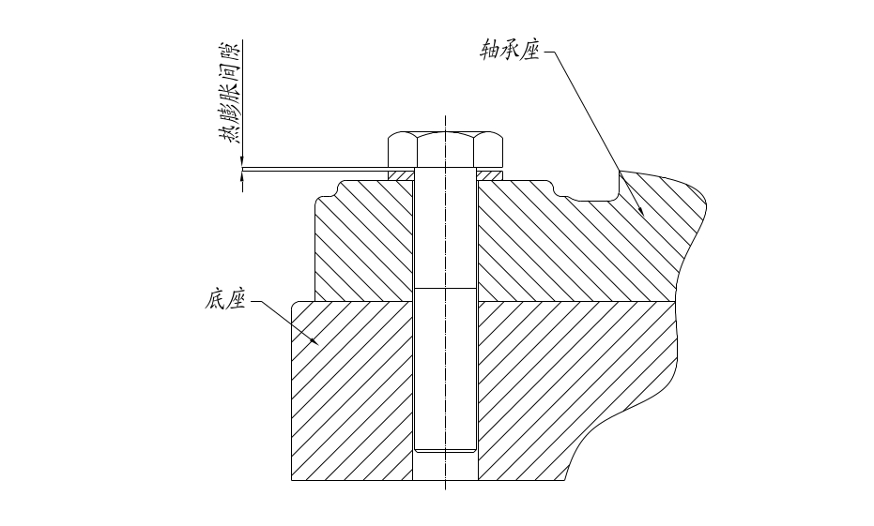
Sketch 2-2 Expansion Clearance Sketch between Bearing Seat and Pedestal
图2-2轴承座与底座螺栓热膨胀间隙示意图
2.7转子
转子由主轴、叶轮、轴套、平衡盘、推力盘和联轴器组成，除主推力盘、联轴器与主轴之间采用键联接外，其余各零件与主轴之间均采用适当的过盈配合。叶轮、主轴等关键零件都进行了精确的强度校核，具有足够的安全系数，叶轮加工完成后根据工作时的圆周速度不同，按工作转速110-115%进行超速试验以确认其强度；利用可靠的计算程序对的转子的动力学特性进行校核，确保转子的工作转速与临界转速之间有足够的隔离裕度，使转子可靠稳定的运转。转子是风机的心脏部件在吊装、运输和保管环节中要特别注意不得磕碰和锈蚀，并定期转动以免发生永久性变形。
2.7 Rotor

Rotor is composed of main shaft, impeller, shaft sleeve, thrust disc and coupling. All the components are connected with the main shaft by proper interference fit except main thrust disc and coupling is connected with the main shaft by the key. The main components like shaft and impeller have been done the accurate strength check, owning the enough safety factors. After the impeller is fabricated, the strength test shall be carried out as per the normal running speed’s 110-115% to confirm its strength. Check the rotor dynamics through the credible calculating program to guarantee the rotor running smoothly. The rotor shall be protected from crash and rust during the hoisting, transportation and keeping. Turn the rotor at a regular time to avoid its deformation.

2.8联轴器与护罩
鼓风机与电机或汽轮机之间均采用膜片式联轴器连接或齿式联轴器连接（详细参数见相应的说明书），通常轴端的半联轴器是连同转动部件同时平衡的，中间套则是单独平衡的也不做标记，如果联轴器是整体平衡时安装时则要注意标记的对应。联轴器外安装有防护罩是安全保护装置，一般为水平剖分结构，固定与鼓风机和电机之间的基础上，或者是端面连接在固定元件上，以防止人员靠近联轴器发生意外。
2.8 Coupling and Shelter

The diaphragm type coupling or dental formula coupling is adopted for connecting the blower and motor or steam turbine (Refer to the relevant specification for its detail parameter). The half coupling on the coupling end is equilibration with the rotating part, and the middle sleeve is also in separate equilibration state. If the coupling is in equilibration state as a whole, the mark shall be corresponding when installing the same. The safety cover for the coupling is fixed on the foundation between the blower and motor, or connected by the mounted bolts to protect the people from approaching the coupling.
2.9润滑系统
润滑系统是维持机组正常运行的重要单元，大型离心鼓风机均为强制供油方式对鼓风机及其他用润滑油的部位进行供油，由润滑油站和和高位油箱共同构成运行保安系统，油站由双联电动油泵、集中油冷器、过滤器、调压阀组、高位油箱和油管路等组成。
2.9 Lubrication System

Lubrication system is an important part to maintain the blower unit working normal. The forced feed oiling manner is adopted by the huge centrifugal blower. The lubrication system is composed of lubrication station and top lubrication tank, and the lubrication station is composed of duple electric oil pump, centralized oil cooler, filter, pressure adjustable valve unit, top lubrication tank and oil pipelines.
2.9.1油站：油站为整体装配稀油站，全部设备、仪表（就地）均安装在一个共用底座上或油箱上（高位油箱除外）。稀油站润滑系统布置在标高为+0.25米结构平台上。由贮油箱、双联电动油泵、双联板式（或列管）油冷却器、双筒网式过滤器、高位油箱、调压阀、安全阀、检测仪表，将上述组件联通的连接件、就地仪表盘等组成。油箱有效容积、油冷却器的换热面积、油过滤器的过滤精度等详见润滑油站使用说明书，润滑油站布置的高度以回油流畅为原则，落差过高不利于油压的调整。
2.9.1 Lubrication Station: the lubrication station is the integral equipment, all the devices and instruments are installed on the common pedestal or oil tank (except the top oil tank). The lubrication system is located on +0.25m platform, which is composed of oil tank, electric oil pump, oil cooler, filter, top oil tank, pressure adjustable valve, checking instrument, connecting fitting and instrument panel. Refer to the lubrication station specification for the oil tank efficient volume, oil cooler heat exchange area and filter parameter. The lubrication station located height shall be proper for the smoothly returning the oil, if the located position is too high, it is difficult to adjust the oil pressure.

2.9.2高位油箱：由钢板卷制焊接而成的立式或卧式圆筒形，布置于鼓风机轴心线上方5米以上的任何制定位置。高位油箱容积的确定原则为：在突然停电或其他事故及电动油泵亦无法投入运行时，高位油箱内的润滑油因位差产生压力来供油润滑，供油时间不少于3分钟。
2.9.2 Top Oil Tank: the vertical or horizontal cylinder type oil tank made from the steel plate is fixed on the 5m above the blower axis. The function of the top oil tank: if meeting the power failure or other accident leading to the electric oil pump not work, the oil supply can be continued from the top oil tank. Oil supply time shall be not less than 3min.

2.9.3油站系统图：详见润滑油站使用说明书
2.9.3 Lubrication Station System Drawing: refer to the lubrication station operation specification.
2.9.4润滑油的技术规范：
润滑油牌号：N32 L—TSA透平机油（GBLL120—1989）
在40℃时的运动粘度：28.8～35.2㎜²/s
粘度指数：≥90
闪点℃（开口）℃：≥180
倾点℃：<-7
注：不符合此技术规范要求的润滑油，可能会损坏鼓风机的支撑元件而损伤转子。
2.9.4 Tech norms of lubricant oil
Lubricant oil Type ：N32 L—TSA Turbine oil（GBLL120—1989）
The coefficient of kinematic viscosity at 40℃：28.8～35.2㎜²/s
Viscosity index：≥90
Flash point ℃（aperture）℃：≥180
Pour point℃：<-7
Remarks: If the lubrication oil doesn’t meet the requirement of the tech norms, it will damage the supporting parts of blast blower and the rotor.

2.9.5冷却水
冷却水水质的浊度＜5ppm为宜，PH=7.7，水温一般要求＜30℃.最高不超过32℃.水管管道不应暴晒在日光下。
2.9.5 Cooling water
The turbidity of cooling water should be ＜5ppm, PH value is 7.7, and the water temperature should be ＜30℃, and the highest should not be higher than 32℃. The water tube should not be exposed to the sunlight.
冷却水进水压力应比进入冷油器的油压略低，以确保在万一发生泄漏时油里混不进水。
The inlet pressure of cooling water is lower than that of oil cooler, so t water will not mix with oil in case of leakage.
2.9.6润滑系统及其油管路应置于阴凉处。油站油泵中心线与机组中心高差一般≤3m。油箱的基础应便于油箱换油及清理。回油管沿回油方向应有3～5%的坡度，进油管按进油方向应有1-3%的坡度。油管不得有Ω型弯管，不得已时应设放气阀门。
2.9.6 The lubrication system and fuel pipes should be put in the shade. The height difference between oil pump central line and machine unit central should be ≤3m. The basement of oil tank should be cleaned and oil should be recharged easily. The slope degree of Oil return pipe towards the oil return direction should be 3～5%, while the slope of the sucker towards the filling direction should be 1-3%. Elbows should not appear in the oil pipe, and bleeding valve should be set up if necessary.

2.10轴向位移监测详见《轴向位移测量系统说明书》。
2.10 The details of axial position monitoring see the Specification of Axial Position Measuring System.

2.11电机和汽轮机作为驱动原动机由于工作原理的不同，安装和使用时的要求也不同，必须按照所提供的产品证明说明书进行调试，以避免发生不可回复的故障。
2.11 As the priming mover, because of different working theories, the requirement of installation and using methods of the motor and steam turbine are different, therefore, the adjustment should follow the Products Specification so as to prevent the failure.

2.12控制系统
控制系统包括电气控制与自动控制。本说明仅对控制范围做概要说明。详见按成套设备合同之规定提供的电控与自控说明书。
2.12 Control system
The control system covers electric control and automatic control. The specification only explains the control scope. The details see the electric control and automatic control specification contained in the equipment contract.

2.12.1自动控制系统
自动控制系统包括：
A、对机组全部运行参数的监控就地监视，控制室集中监视；
B、鼓风机的防喘振调节系统，防逆流调节系统等；
C、电机和汽轮机的监视与保护；
D、汽轮机调速控制系统
E、非正常工况和运行参数超限时的监控；
F、为机组的启动、运行、停车提供控制信号和连锁；
2.12.1 Automatic control system
The automatic control system consists of:
A、Monitoring all the unit operational parameters in the control room.
B、The antisurge regulating system of blower and anti-reflux regulating system, etc.
C、The monitoring and protection of motor and steam turbine.
D、Speed setting system of steam turbine
E、The monitoring of improper working condition and overtime of operational parameter.
F、Providing control signal and interlock for the start, operation and shutdown of unit.
2.12.2电气控制
A、高压电气控制主要有原动机的启动、停车；电气参数的安全保护、报警和连锁
B、低压电气控制主要有盘车装置、电动泵、加热器、排油雾风机、水泵、电磁阀、各种电动阀门等的启动、停车控制和保护。
2.12.2 Electric control
A. The high-voltage electric control mainly includes the start and shutdown of priming motor, the safety protection, alarm and interlock of electric parameter.
B. The low-voltage electric control mainly includes the start, shutdown control and protection of all kinds of electric valves, such as the barring gear, electrical pump, heater, vapor exhaust fan, water pump and magnetic valve.

2.12.3控制系统的设计原则简述
2.12.3 Design Principle Description for Control System
控制系统中包括了机组的启动和停机、重要运行参数的显示、系统压力、润滑油压力及温度、机组振动、轴向位移方面能正常安全运行所必须的仪表连锁报警装置。基本的控制系统是按恒压力运行而设计的。
The control system includes start/stop the blower unit, display of important running parameter, system pressure, lubrication oil pressure /temperature, vibration of the blower unit, axle displacement and other instruments interlock alarm devices. The basic control system is designed as per the blower unit running under the constant pressure condition.
大型离心压缩机在小流量运行时的喘振是其固有属性，其表现特征是剧烈的震动并伴有喘息声有着极强的破坏作用，在控制系统中设计的防喘振保护装置，是在即将发生前打开阀门调节系统的流量和压力，可避免鼓风机在非稳定的喘振工况运行。喘振的发生是当用户管网阻力增大到某一值或流量减小至某一极限值时，就会出现压缩机和管网的气流呈现周期性哮喘的现象，同时伴随有管网的压力和流量大幅波动，并伴有异常噪声这种现象就是压缩机的喘振。轻微的喘振会造成工艺流程中参数的波动，严重喘振甚至会使整个压缩机机组受到严重损坏。因此压缩机严禁在喘振区域内运行。
The huge centrifugal compressor owns the characteristic of surging, which means the strong vibration and gasping owning destructive effect will happen when the compressor is running with the small flow quantity. So the vibration and gasping proof device is designed to open the valve adjust system flow rate and pressure before the vibration and gasping happening, which can avoid the compressor running under the unstable vibration condition. When the pipeline resistance increases or decreases to a limiting value, the periodical gasping of the compressor and pipeline air flow with the pipeline pressure and flow quantity great fluctuation and with the abnormity noise will happen, this phenomenon is called the compressor gasping. The light gasping can cause the fluctuation of the process parameter, while the heavy gasping can badly damage the whole compressor unit, so the compressor is not allowed to work under the gasping condition.
全套控制系统都预先作好设定，只要联接上电源、干燥的仪表和控制空气即可投入操作运行。
All the control system shall be preset to guarantee its normal working when connecting the power, instrument and other devices.

控制系统原理详见图“离心鼓风机流程图”和“离心鼓风机报警联锁逻辑图”。
Refer to the Flow Chart of Centrifugal Blower and Alarm Interlock Logic Diagram of Centrifugal Blower for the detail control system principle.
控制系统运行操作方式详见《防喘振装置说明书》。
Refer to Vibration/Gasping Proof Device Instruction for the control system operation/running manner.
3.0 安全
3.0 Safety
3.1序言
本说明书作为买方对离心式鼓风机的安装、操作运行以及维护工作的说明，鼓风机在设计时可以安全而可靠的工作。所要强调的是离心鼓风机属高速重载的旋转体，同时整个系统带有一定的压力，因此准确的操作和判断至关重要，本说明书的提示是供在操作和维护离心式鼓风机方面受过培训的人员必须要掌握的基本常识。
3.1 Preface
This specification introduces erection, operation and maintenance for centrifugal blower. Because the centrifugal blower whose system have stated press is rotator with high speed and heavy loading, the accurate operation and estimation is very important. The content of specification is based on master technic of trained operators.
3.2安全程序
首先要求买方的安全部门根据对工业方面危害的全面分析，需要制定出一整套安全操作程序和异常运行状态预案，以及在说明书中所明确的鼓风机的重要内容要求操作人员要熟记，保证将由高速旋转机械所造成的各种危害都涵盖进去。
对于存在电流、油、带压气体带来的危害，给予足够的重视。安全保护系统、停机装置以及超压保护设备的正确安装和管理也应属于安全程序的主要组成部分。
采取特殊预防措施是必要的，如防止在进行设备维护工作时，电源接通设备的可能。也不能忽视由于反向流动而引起的旋转，在维护期间关闭截断阀、插入盲板、加挂标志，都是安全维护的常识。
在一般情况下，所有的人员都应遵守与设备和操作过程相关的安全基本规则。
3.2 Safety procedure
Firstly, the safety sector of purchaser need analyze hazard factors in industrial aspects. Secondly, according to analysis datas to make out the safety operation manual and abnormal running scheme. Many hazard factors made by high speed rotator need be included in this specification and some important contents should be kept in mind by operators.
Pay much more attention to the hazard of current, oil and gas with pressure. The main component parts in safety procedure include safety protection system, stopping device and installation and management of over-pressure protection equipments.
Special preventive measures are necessary, if the equipment maintenance is working, please notice the power. The rotating resulted from reverse flowage is not ignored. These are basic knowledge in safety：closing block valve, inset blind plate and hanging the label during maintenance.
All workers should abide by Safety Rule of equipment and operation.
3.3安全步骤
以下安全步骤应和操作人员手册中所载的安装、操作和维护指示说明一起使用。
3.3 Safety steps
The following safety steps are used with installation specification, operation specification and maintenance specification.
3.3.1准备在装置上进行工作维护之前，应该先拉开隔离开关，如果采用了任何单独的控制线时，也要将它断开。
3.3.1 Please make sure close isolating switch before maintenance. Cut off switch even if it uses separate wire.
3.3.2在未消除（释放）整个系统的压力之前，切勿拆卸机器上的任何零部件。
3.3.2 Don’t allow dismantling any parts on machine before decompression of system
3.3.3在运行中的机器，切勿进行在线检修维护。
3.3.3 Don’t allow repairing on line when the machine is working.
3.3.4对变转速驱动的鼓风机，切勿让转速超过鼓风机铭牌所标明的额定转速。
3.3.4 Don’t allow using non-standard rotating speed(it means that use rated rotating speed on brand of blower) for blower with variable rotating speed drive
3.3.5鼓风机的控制室不宜建在鼓风机旋转部分的径向方向。
3.3.5 The controlling room of blower is not suitable to be built on radial direction of blower
3.3.6在鼓风机运行时，不得解除任何保护装置。
3.3.6 Don’t allow dismantling any protection devices when the blower is working.
3.3.7要定期检查所有安全设备，是否运行正常。
3.3.7 Check out all safety equipments whether is normal or not at fixed period
3.3.8合缸盖前要确认没有工具、抹布或任何外来零件留在鼓风机内
3.3.8 Before closing the cover, please make out that there are no instruments, duster cloth or any parts in blower.
3.3.9切勿使用易燃溶剂清洗零部件。
3.3.9 Don’t allow using flammable solvent to clean parts
3.3.10切勿用压缩空气打斗嬉戏，有压力的空气会严重伤人。
3.3.10 Don’t allow playing with compressed air otherwise it will hurt somebody.
3.3.11在维修时，可以用干净的布块或牛皮纸，盖住零件或暴露在外的孔口，使污物不落入鼓风机内。
3.3.11 Cover the parts or holes with clean cloth or kraft paper in case of the dust when it is on maintenance.
3.3.12当未安装好保护装置、防护罩和滤网时切勿让鼓风机运行。
3.3.12 Don’t allow working of blower when the protection device, safety hood and filter screen are not installed.
3.3.13不要让鼓风机在可能会吸入易燃气体或有毒烟雾的地方运行。
3.3.13 Don’t allow blower running in flammable gas and toxic smog.
3.3.14千万不要将排放的空气用于医用空气供呼吸用，它会造成严重伤害，甚至引起死亡。
3.3.14 Don’t allow using waste gas as medical air otherwise it will cause serious harm or even death
3.3.15带有压力的油、空气混合物是危险的，会造成人身严重伤害或死亡，在特定的条件下，高压混合气体也会发生爆炸。
需要特别提示的是鼓风机的操作人员，如果不遵守常规通用的安全预防措施，都有可能造成设备损坏和人身伤害。
若不遵守国家、行业和卖方安全之规定和其他普通预防措施，或者没有注意到在操作和装卸搬运鼓风机时需要主要的事项（即便在上面没有明确规定），卖方明确表示对此造成的伤害或损失，不承担任何责任和义务。
3.3.15 The oil with pressure and air mixture is so dangerous that it will cause serious injury or lose life. Under special conditions, the high pressure mixed gas will explode.
We should suggest the operator of blower that it will cause equipment damage and serious harm for health, if you can’t abide by safety measures.
The purchaser will be responsible for self action, if the purchaser can’t abide by any safety rules (Nation Safety Rule, Industry Safety Rule etc.) and some points for attention in the process of operating and transporting(even if no definite provision)
4.0接收、搬运、存储
4.0 Receiving, Transportation and Storage
4.1接收
鼓风机在出厂以前卖方已经经过质量核查和考核，而且装货时是严格按装箱单进行清点过，以保证设备在装货过程中不受损伤，并且所有必要的附件均已登记确认。并编制发货清单随货物发往买方。
4.1 Receiving
The seller has checked out the quality of blower after completing production in factory and counted this equipment as shipping list in case of damage in the process of loading. The important attachment has be registered and affirmed and will be dispatched with shipping list.
买方在收到设备后，应先检查所收到设备及包装箱是否在运输过程中受到损伤，是否与发货清单相符并在回执上签收。若发现有任何损伤迹象和短缺，应详细记录并立即通知卖方和货运单位。到货后应书面通知卖方到现场会同卖方及相关施工单位点件验收，并转由买方或相关施工单位负责保管。

After receiving the equipments and package, the purchaser should check them whether are identical with shipping list. If these equipments and packages are not damaged, the purchaser could sign on receipt. If the purchaser finds equipments damage or shortage, please record detailedly and immediately inform seller and shipping unit. After receiving equipment, written notice is sent to seller and then checked them with seller and construction unit. At last the purchaser and construction unit take care of them
到货后，要阅读看懂所有的包装箱外的标志和指示说明。注意阅读使用说明书有关储存、保管的重要内容和注意事项。
After receiving the goods, please read and understand the marks and specification. Specially, storage and attentions
除了单独另行包装的以外，鼓风机包括的所有项目（零部件）在接收时都要按装箱单确认，核查是否存在短缺，所有项目的技术文件和鼓风机一起或者单独发送的，应登记造册妥善保管。以防资料丢失、滥用或被盗用。
All parts of blower must be confirmed as shipping list apart from separated package. All technical documents and blower parts should be registered and take care of them in case of loss or abuse.
4.2搬运
应该请有资质和有经验的公司搬运和安装鼓风机队伍进行吊装和搬运，切勿用鼓风机或驱动机的吊环起吊该装置。这些吊环只供检修中起吊单个零件之用。如果误用这些吊环，会造成人身和设备的损伤。
4.2 Transportation
The company with qualification and experience is invited to transport and install blower. Don’t use the slinger of blower or drive to sling this device otherwise it will cause life harm and equipment damage. These slingers are used as sling separate part on maintenance.
4.3存储
4.3 Storage
4.3.1安装前存放
若机器和部件不能马上安装，应将它存放在通风、干燥、干净、阳光不能直接照射和温度波动不大的库房。包装箱一般不允许堆叠。
机器的加工表面涂有防锈漆或防锈油，若涂层部分脱落，则应用清洗剂将全部涂层洗掉，清除水和锈后重新涂漆或油脂，但涂抹前必须完全干燥以保证涂层牢固。
如果机器存放在六个月以上，防锈层会失效，之后的每三个月检查一次防锈层，以确认防锈层完好，如失效应重新进行防锈处理。
4.3.1 Storage before installation
Before installation, the machine and its parts should be stored in storehouse where the condition is ventilation, dryness, no dust, avoiding direct sunlight and stable temperature. The packages are not allowed stacking.
The finished surface of machine is painted antirust paint or antirust oil. If the paintcoat drop off, firstly wash the coat with detergent and then clean the water and rust. Lastly, paint or grease after surface drying.
The valid period of antirust coat of machine is six months. If the life of antirust coat is more than six months, please check it every three months. Please paint antirust renewedly when the antirust coats lose effectiveness.
4.3.2安装后的存放
机器安装后的存放有两种情况：一是存放一段时期暂时不运行，二是作为备机用。
4.3.2 Storage after installation
The machine storage methods after installation：1 the machine is stored for a time.2 the machine is used for spare
4.3.3存放一段时间 Store for a while
a)将裸露部分涂上防锈油，若部分不涂则易导致所有涂层部分锈蚀。要特别主要轴颈的表面的保护和防锈。The naked area should be painted antirust oil. If the paintcoat area is not painted fully, which will cause all areas tarnish. The protection and antirust of surface for shaft journal is very important.
b)关闭进出口冷却管的排泄阀，将中间冷却器内的水通道内的水排尽并吹干。Close the release valve of import and export cooling pipe, drain water of middle cooler and blow-dry
4.3.4长期存放，存放过程中的维修和检查 The maintenance and inspection in the process of long storage
如鼓风机要在六个月以上的存放期，在此期间不仅要防止锈蚀，而且应防止保护系统的失调而引起的恶化或损坏，定期检查对于使压缩机处于良好条件下是非常重要的,检查的详细及保护性维护如下：
If the storage time of blower is more than six months, you must check compressor at regular intervals. The blower is not only antirust but also prevented protection system damaging or worsening; the following is detail inspection and maintenance:
A、其他存放部件的检查
存放三个月之后，检查涂有防锈剂和分开包装的部件，如稍微发现生锈或防锈层已经损坏，应重新涂有防锈剂并牢固包装，根据以上检查结果定期（3至6个月）重新检查。
注：雨季存放应特别注意检查。
- the inspection of other storage parts
After three months, Please check the parts of painting antirust and separate packing. If you find the rust or antirust coat broke, please paint antirust renewedly and pack firmly。Check renewedly storage parts at fixed time(three to six months)
Note: pay much attention to storage parts in rainy season
B、外部表面的检查
部件的外部表面应涂漆防锈。但长期存放也会生锈。一般多因潮湿，通风不良造成，所以应 定期（3至6个月）检查外部表面，如生锈。则立即改善存放地点的现状，使之驱湿通风，并应重新涂漆该部件。
B, The surface inspection
The surface of parts should paint antirust. Check the outer surface of parts at fixed time(three to six months).If the surface rusts, please change the storage environment and then paints renewedly.
4.3.5按备用设备存放
每周运转辅助油泵一小时或一小时以上，冲洗润滑油系统，盘转鼓风机一次，转子翻转180°或90°。经常往中间冷却器注最小量的水，以保持水新鲜。
4.3.5 Store for spare equipment
Rotate auxiliary oil pump for an hour or more every week; Flush lubricating system every week; Every week, rotate the blower once and rotate the rotor to 180°or 90°; Usually, Pour little water to intercooler to keep the water fresh
5.0安装 Installation
5.1一般介绍
要使高速转动的机械满意地投入运行，正确的安装至关重要，需要对机器进行良好的安装，才可以用最低的运行费用，达到最可靠的工作要求。基础（地基）和管道的设计要求设计者对当地的情况有充分了解，建议买方由对机器基础具有设计资质，并且有经验的人员承担此项设计任务。
可以参阅卖方提供的鼓风机组总体布置图，以及鼓风机组的相关参数与买方设备联接的细节。
5.1 General introduction
The installation is very important before machine running. The designer should understand the design requirement of foundation and pipe .It is suggested that the purchaser should have design qualifition of mechanism and the experienced operators are employed to complete the task.
Refer to general arrangement of blower and some details between related parameters of blower and equipment linkage
5.2起吊
应利用机房内专用起重机安装鼓风机组，在底板上已经为起吊整个装置留出了起吊点。
5.2 slinging
The special crane in computer room is used for installation of blower uint. The lifting point has be reserved at the bottom plate.
5.3基础（地基）
高速旋转机械的基础虽然不需多么笨重庞大，但是应该足以给机器提供一个永久的刚性（不会扭曲）平台。要做到这一点基础周围的所有条件应该是均匀一致的，即基础要安全撑放在牢固的地面上。支撑在桩基上的基础一定要用厚重的整体组合平台面，不连续的基础可能会使基础下沉不均匀，导致机器对中破坏。
5.3 Foundation
The machine should be provided with permanent platform. The all conditions should be uniform. If the ground is not flat, the platform will sink to cause the machine damaged.
温度也应该均匀一致，否则机器可能出现变形和对中不准的结果，如果基础的一段比另一段的温度差很多的话，就可能有这种现象。
The temperature should be uniform otherwise the the machine will be deformed.
用钢筋混凝土和钢结构组合的基础，基础结构决定的固有频率必须避开鼓风机的共振频率。
The foundation is combined with concrete and steel structure. The inherent frequency of foundation structure must avoid the resonance frequency of blower.
注意：基础的设计工作是买方的任务，提供上述意见作为买方的参考，以保证机器安装运行成功，卖方对基础设计不负任何责任，建议买方征求在机器基础设计方面有经验的专家意见。
Attention: the design is the task of purchaser. The above advices are provided to reference. The purchaser should be responsible for design of machines, hereby the purchaser should consult the advices of experts.
机组（鼓风机、电机或汽轮机）的基础不应与其他建筑物相连接。
The foundation of unit (blower, motor or steam turbine) is not connected with other buildings.
对于大型三元流离心鼓风机设备基础，在设备安装前要求买方提供以下基础验收资料
Before centrifugal blower installing, the purchaser should supply the following acceptance information
A、基础中心线、标高与厂房基准线偏差值检查记录；
A, The deviation value for centre line of foundation, elevation and datum line refer to record
B、基础外形尺寸检查记录；
B, The outline dimension refer to record
C、基础混凝土强度检验报告；
C, The test report of foundation concrete strength
D、基础测振资料——应使用基础的固有频率避开机器振动频率；
D, Measured vibration data of foundation-the fixed frequency should avoid vibration frequency of machine
E、基础沉降值检查记录；
上述要求其验收标准除按国家及部委颁发的有关验收规范外，卖方同时提出下列内容：
E, The checking record of sedimentation value
The seller gives the following advices.
1）对基础进行外观检查，要求表面平整、无蜂窝、无露筋、无裂纹等。用0.5～1磅手锤击检查，不应出现空层现象。
1) Check the outer surface to make sure that the surface is flat and use hand hammer(0.5-1 pound) to check whether it is empty.
2）基础中心线与厂房轴线间距允许偏差±20毫米。
The allowable error of space between central line of foundation and axial line of plant house is ±20mm
3）基础各不同平面的标高允差±10毫米。
3) The allowable error of elevation on different plan is ±10mm
4）基础上平面的不水平度允差5毫米/米，全长允差为10毫米。
4) The allowable error of plan levelness on foundation is 5mm/m.The allowable error of total length is 10mm.
5）基础上平面外形尺寸允差20毫米。
5)The allowable error of overall dimension of plan on foundation is 20mm
6）地脚螺栓孔中心允差±10毫米，预埋地脚螺栓中心允差±20毫米。
The allowable error in the center of foundation bolt hole is ±10mm. The embedded allowable error in the centre of foundation bolt is ±20mm.
7）地脚螺栓孔垂直度总允差为螺栓长度的1%
7)The total allowable error of perpendicularity for foundation bolt hole is 1% bolt length.
8）与锚板相接触的平面应平整，其水平度允差为5毫米/米，其标高允差为±20毫米。
8)The plan connected with anchor plate should be flat, whose the allowable error of levelness and elevation is 5mm/m and ±20mm
9）平面凹凸部分允差±20毫米。
9) The allowable error between concave and convex part: ±20mm
10）沉降试验时，在基础面上预压相当机器组总重量1.5倍的重物，观测沉降的时间应在24小时以上。原则上应以基础基本不沉降或经过有限的微量均衡沉降后不再出现沉降现象为标准，对于出现沉降量偏大或偏斜现象均不允许。
10) The pressure on ground is 1.5 times of the total weight of machine unit when the settlement test is doing. The observation time is more than 24 hours. There are not settlement phenomena on settlement test, which is best principle.
5.4机组安装
5.4 Machine assembly
5.4.1整个机组安装应以增速器中分面为基准，两端延伸至鼓风机和电机或汽轮机按联轴器找正要求，保证鼓风机、汽轮机之转轴中心线近似地成为一条光滑的弹性曲线（见图5-1）
5.4.1 Entire Machine assembly should be conducted basing on mid-separate surface of speed increaser, and its two ends should be extended to the alignment line of motor, blower or steam turbine’s coupling shaft to guarantee that the C/L of rotating shaft of blower and steam turbine is approximately shaped like a smooth elastic curve(refers to 5-1).
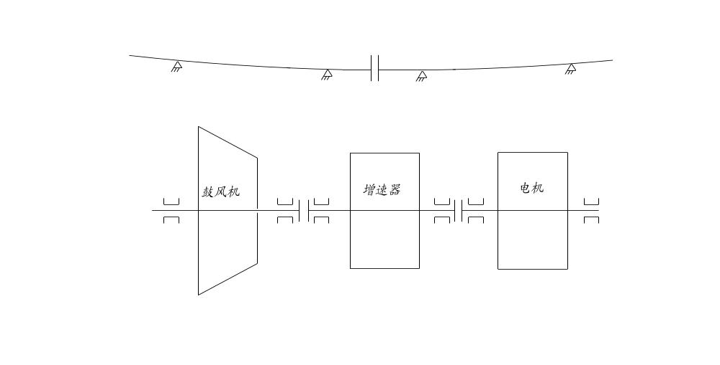
Blower

coupling

Motor

图5-1机组找正示意图
5-1 machine assembly alignment sketch
5.4.2鼓风机的安装技术要求：
5.4.2 Technical requirement for Blower assembly:
5.4.2.1将鼓风机的底座、楔形垫铁组及下机壳分别放置在水泥基础上，注意吊装定子下半部时，应将进口、出口短接管与机壳的进、出口管法兰连接好，再吊放于水泥基础上的底座上。
5.4.2.1 Base seat ,wedge-shape sizing block unit and downside shell of blower should be laid on cement foundation respectively, attention: during the downside part of stator hoisting period, firstly good connection between outlet./inlet of short pipe and shell’s outlet./inlet pipe flange is required, then lay it down carefully to base seat of cement foundation.
5.4.2.2将支撑和止推轴承分别装于轴承箱内，用着色法检查固定衬板与轴承箱表面的接触情况，要求接触均匀，接触面积不得小于75%（见图5-2），
5.4.2.2 Support and thrust bearing should be installed in bearing box respectively, and touching condition between the fixed lining plate and bearing box surface should be tested by coloring method; touch face should be even, and its area should be 75% or more (refers to 5-2).
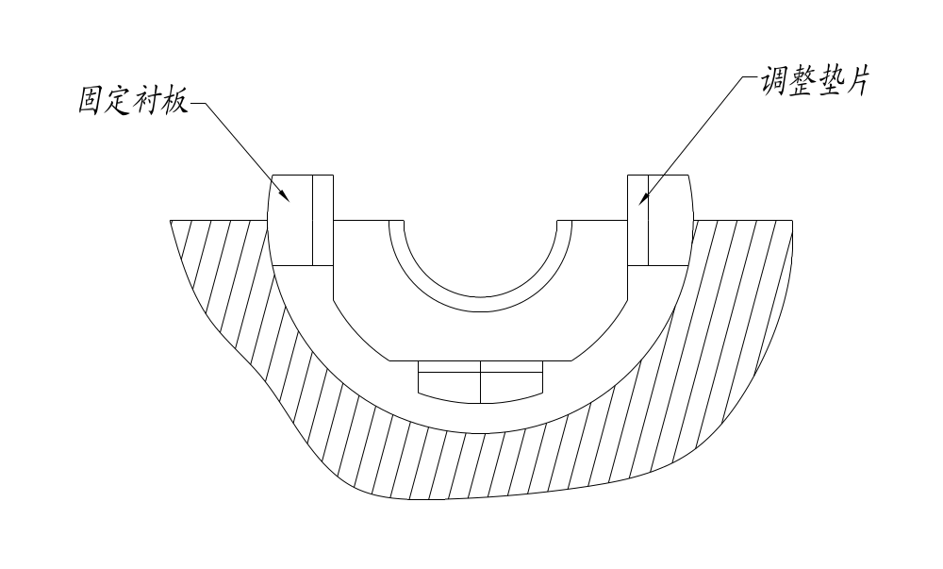
图5-2轴衬与轴承接触情况示意图
5-2 Bearing lining and bearing touching condition sketch
5.4.2.3在转子吊装时吊索应可靠等长，所吊装转子必须保持水平避免碰坏止推块（或止推瓦）表面（见图5-3）。
5.4.2.3 When rotator is hoisting, the hoist string should be reliable and equal-length, and the hoisted rotator should be keeping level and avoiding damaging the thrust block(or thrust bearing) surface. （5-3）
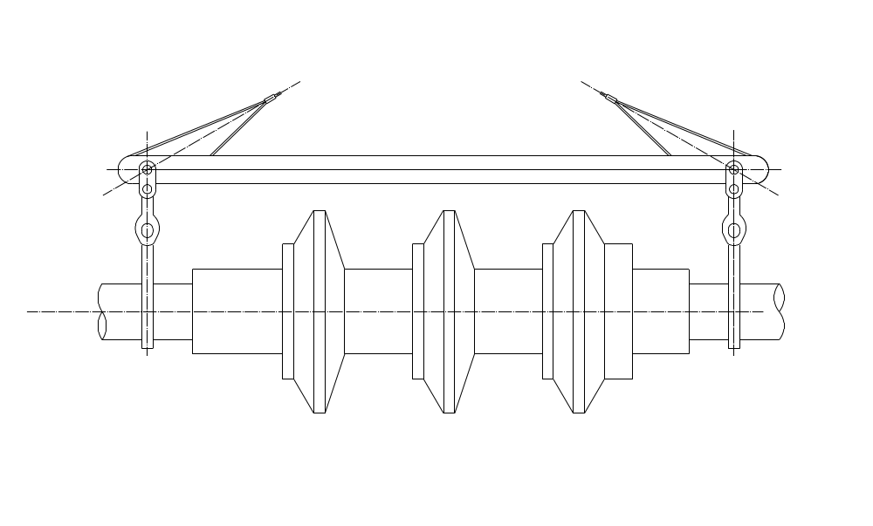
图5-3转子吊装工具示意图
5-3 rotator hoist instrument sketch
5.4.2.4检查转子上各轴颈上与定子相应的各轴孔是否保持同心。
5.4.2.4 To check whether each rotator neck and stator’s responding bearing hole are in the same C/L.
5.4.2.5检查轴颈与轴衬接触情况，在轴颈上涂上红丹涂料，按运转方向盘转子数周，吊出转子观察轴衬表面的接触痕迹，要求接触均匀，下轴承接触角不小于60℃，但接触部分不允许有明显的分界线（见图5-4），否则应经刮研达到要求（四油叶或五油叶轴承在加工时就控制了误差原则不许刮研）。
5.4.2.5 To check bearing neck and bearing lining’s touching condition, red lead paint should be painted on bearing neck. To run the rotator many times as per running direction, then hang out of the rotator, to check the touching trace of the bearing lining surface, it is required that the touching face should be even, and the down bearing touched angle should be 60℃ or more. The touched part should not be significant separate line(refers to 5-4), otherwise rescrape is needed to meet the requirement. (Four oil blade or Five oil blade bearing is controlled deviation during processing, so rescrape is theoretically no need.)
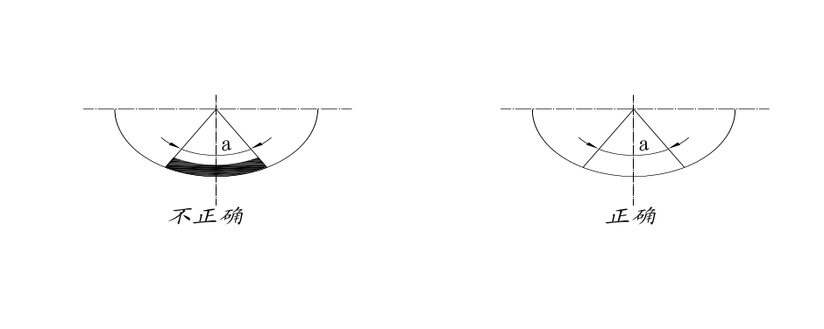
Not correct

correct

a为30°-45°
a is 30°-45°
图5-4轴与轴衬接触情况示意图
5-4 Bearing lining and bearing touching condition sketch
5.4.2.6采用压铅丝法检查轴承间隙，轴承与压盖的过盈值要求为0.03-0.05mm。轴承的顶间隙、侧间隙及推力面间隙值应符合产品证明书的规定值（见附图表一）。
5.4.2.6 to check the bearing gaps by pressing lead wires, and the interference value is 0.03-0.05mm. Top gap, side gap and thrust side gap values should be accord with product certificate(appendix 1)
5.4.2.7检查各梳齿形密封和油封的径向间隙，轴向间隙，各叶轮与扩压器的对中等应符合产品证明书的规定值（见附图表二）。
5.4.2.7 To check the diametric clearance and axial clearance of each comb teeth-shaped sealing and oil-sealing, C/L alignment of each impeller and diffuser should be accord with the regulation listed in Product Quality Certificate (refers to attached sheet 2).
5.4.2.8检查转子各部位的径向跳动值、端面跳动值应符合产品证明书上的规定值（见附图表三）。
5.4.2.8 To check the rotator’s each part ‘s radial runout value, and end face runout value be in line with regulation value listed in Product Quality Certificate (refers to attached sheet3).
5.4.2.9装上导向杆，将定子上半部吊装上，用塞尺检查其水平分面的自由间隙，其允差为0.08mm，为防止运转时漏气，允许在其中分面上涂一层极薄的密封涂料，例如南夫704胶等。
5.4.2.9 to install guiding bar, and the upper part of stator (by hoisting), and measure its free clearance in horizontal direction by filler gauge with a 0.08mm tolerable deviation. To prevent the air leakage during running, it is allowable to coat a razor-thin sealing painting on its mid-split face. Such as NANFU 704 glue etc.
5.4.3电机或增速器的安装按增速器说明书的要求进行。
5.4.3 Installation of motor and speed increaser should be in accord with Turbine Manual .
5.4.4再以联轴器进行增速器与鼓风机的轴中心相互找正，找正时应考虑到千分表位于最低或最高位置时，由于千分表的自重而引起下堕的影响。找轴端平等度时，应将转子靠紧轴承主推力面旋转，找中心时须轴端互调找正（见图5-5）。在找正过程中，要调整鼓风机、增速器的轴向位置，具体间隙见联轴器装配图。
5.4.4 During the central alignment work between speed increaser and Blower’s bearing which is using coupling, it should consider clock gauge’s self-gravity influence when the clock gauge placed at the highest and lowest location. When the bearing tip alignment work is conducting, the rotating rotator should be tightly closed to the bearing thrust face; when central line is aligning, the bearing end should be mutually aligned ( refers to5-5 ). During alignment work, bearing direction of blower and speed increaser should be adjusted, detailed clearance refers to coupling assembly drw.
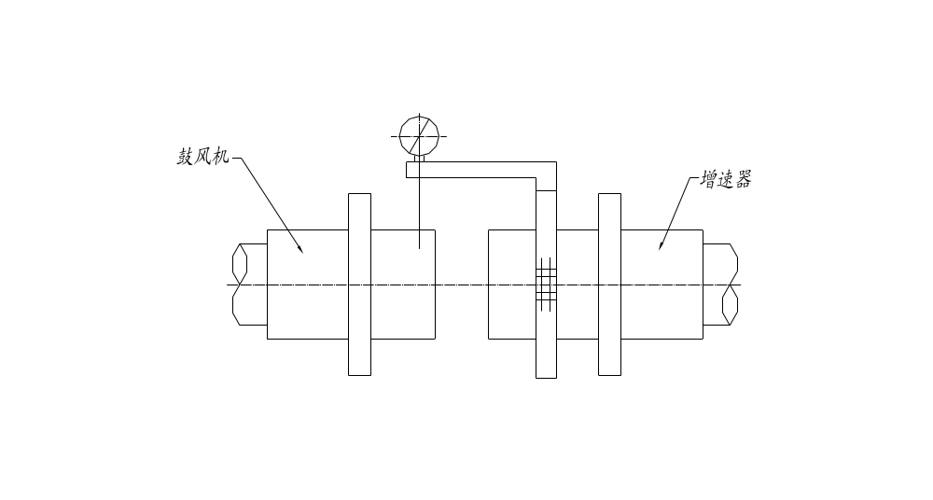
Blower

SPeed increaser turbineturbine

图5-5联轴器找正示意图
5-5 coupling alignment sketch
5.4.5通过底座下的楔形铁来调整鼓风机与汽轮机的轴中心，要求联轴器内套的轴向端跳动允差为0.02mm，圆周径向跳动允差，对鼓风机与增速器为0.02mm（±0.01mm）。操作时一定要使用机座下的螺纹千斤顶进行。
5.4.5 Wedge iron under base seat is used to adjust the bearing centre of blower and stem turbine, 0.02mm deviation of axial direction end pulse is allowable which is in coupling inner sleeve. As for radial pulse of circle allowable deviation, 0.02mm（±0.01mm）is allowable for blower and speed increaser. During operation, screw jack is a must under machine seat.
5.4.6机组中心找正完后，对称均匀地把紧所有地脚螺栓，螺栓固定后重新打表检查各轴同心情况，应完全符合要求。
5.4.6 After the alignment work, all holding bolts should be tightened equally and effectively. And after holding bolts, re-check the alignment condition of different bearings to meet the requirements.
5.4.7对鼓风机和增速器底座下的楔形垫铁进行点焊（见图5-6）。并再次详细检查各部间隙和各轴中心的同心度，确认各项安装工作已完全符合技术要求时，即可对基础进行二次灌浆。
5.4.7 Spot welding is needed for wedge iron under blower and speed increaser(refers to 5-6). And again to carefully check the alignment degree and clearance of every parts. When confirming the erection technical requirement already be reached, secondary grout can be conducted for the foundation.
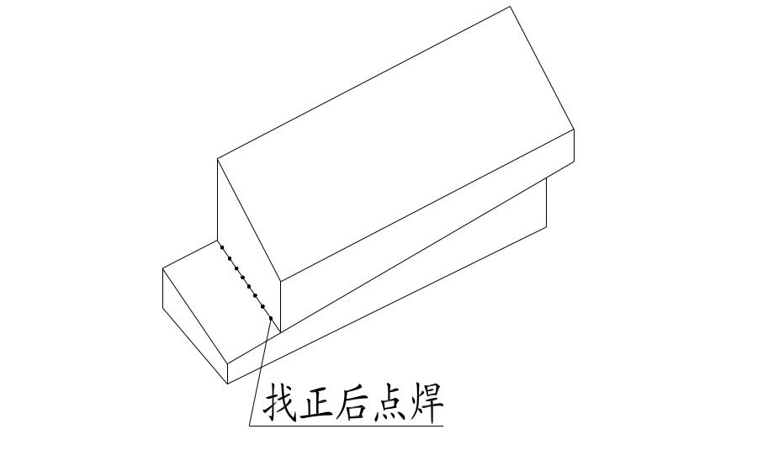
spot welding after alignment

图5-6楔形垫铁放置及点焊情况
5-6 wedge backing iron layout and spot welding condition
5.4.8如果联轴器是整体进行平衡的则按联轴器上打出的标记对号入座安装膜片联轴器。（方法见附图上说明）
5.4.8 if the coupling’s balancing is conducted integratedly , the diaphragm coupling should be erected accordingly as per label on the coupling . （erection instruction is showed in attached drw.）
5.5安装所有进出管线及阀门。安装进出口管线及阀门时，不应使管线及阀门等的重量作用在鼓风机上，应该在适当的部位设置弹性辅助支撑，在出气管路上应安装有缓冲式止回阀和蝶阀，防止气体倒流而造成事故，在出气管路中还应设置两条旁通管路，分别安装防喘振调节阀和手动放风阀，为机组启动和在防喘振区运行放空之用。
5.5 To erect all inlet/outlet pipe and valves. During erection work, weight of pipeline and valves acting on the blower is not allowable, elastic auxiliary support should be set in proper location, buffering- style one-way valve and butterfly valve are needed to ward off air back-flow damage and also two lines of bypass pipelines are needed in air outlet pipeline, and anti-surgery regulation valve and manual bleeding valve should be erected to start machine unit and to empty surgery area running.
5.6安装油站及油管路。安装时应彻底清洗油站各零部件及油管中氧化皮（铁锈）、焊瘤焊渣及其它杂质，各连接法兰间应加石棉橡胶垫（禁止用橡胶垫），油管的清洗应按下列步骤进行：
5.6 Set up oil station and oil pipe. Clean parts and components in the oil station. Remove the oxidization skin (rust), burr, welding slag and other impurities in the oil pipe. Insert asbestos-rubber gasket between connecting flanges (rubber gasket is not allowed). Oil pipe cleaning procedures is as following:
5.6.1焊接部分的残渣及氧化皮用砂轮机清除。
5.6.1 Weld remains and oxidation skin should be removed by abrasive machine.
5.6.2管内用金属刷或带金属刷的铁链子清除氧化皮。
5.6.2 Oxidation skin inside the pipe should be removed by metal brush or metal chain with metal brush.
5.6.3管内用压缩空气吹扫干净。
5.6.3 Compressed air should be used for purging the pipe inside.
5.6.4管内进行酸洗，用1︰15的硫酸溶液注入管内（尽可能不用盐酸）在60℃-85℃的温度下保持30-45分钟，酸洗后用热水洗管，然后用冷清水洗，要求洗后水的PH值与新水相等为止，再用热空气将管内壁吹干（经酸洗中和结束的管路应立即投入油循环）。
5.6.4 Acid cleaning should be adopted for washing the pipe inside. The procedures are: Inject 1:15 vitriol solution into pipe (better not use hydrochloric) and keep it for 30-45 minutes under 60℃-85℃. After acid cleaning, wash the pipe with hot water, then with cold water until the PH value of washed water is equal to the fresh water. After that, dry the pipe inside with hot air (the pipe should be circulated with oil immediately after acid cleaning and neutralization).
5.7安装调整各种仪表，调节好安全联锁装置，并检验其灵敏性。
5.7 Fix and regulate instruments and meters. Regulate the safety interlock device and check its sensitivity.
5.8检查各机体内部是否有遗留的安装工具、料头等，并彻底清除干净。
5.8 Check and take out the installation tools, material scraps etc left in the machine.
5.9整个机组安装完毕时，应对机组进行盘车，并用听棒监听机体内部，应无任何磨刮声，若有应拆盖排除。
5.9 Jack over the whole assembly when the assembly installation is over. Check with listening rod and make sure that there is no scraped and grounding noise inside. Open the cover and clear the noise making source if the noise was detected.
5.10对润滑系统开机前需进行油循环试验，其目的是检查油系统和滤掉管路的杂物，试验前在各轴承和高位油箱进油管的法兰间加多层过滤网，试验时采用的油压应较正常使用的高出0.05-0.1MPa(G)来检查各接头处漏油。试验完毕后将过滤网全部取出进行清洗，反复数次直到完全符合要求后取出多加的滤网方可进行机组试车。
5.10 Oil circulating test should be conducted before lubrication system starts up. The purpose of oil circulating test is to examine oil system and strain off miscellaneous in the pipe. Before oil circulating test, insert multilayer filter screen between bearings and flanges at oil inlet pipe of elevated oil tank. The oil pressure for test should be 0.05-0.1 MPa(C) higher than the normal pressure in order to check whether there is oil leakage at joints. Remove all the filter screens and clean them out after the test. Repeat the process and remove the added filter screens until all requirements are met before the commissioning of the assembly starts.
5.11确认试车前的准备工作已经完成，应首先脱开鼓风机与汽轮机端的联轴器，单独对汽轮机（增速器）进行空载试运转，确认电机或汽轮机转向，轴承温度振动是否正常，一切正常后运行1-2小时。在上述试运转均为正常后才能对机组试车。试车前恍一次车检查鼓风机转子转向是否符合要求，机体内有无磨刮声等，确认一切正常后方可进行试车，一般无负荷运行1小时即可停车，检查并处理解决在试车过程中所存在的问题，当确认全部达到要求时再无负荷运行4小时，运行正常就进行带负荷运行4小时，随后即可投入正式运行。
5.11 Make sure that full preparation has been made before commissioning. First of all, run the sole steam turbine (speed increaser) with no load by disconnecting coupling between blower and steam turbine. Check and make sure that the turning direction of the motor or the steam turbine is right and the temperature change of bearing is normal. If all above is well, the steam turbine should be kept running for 1-2 hours. The assembly commissioning should not be started until all above operation is all right. Check whether rotor of the blower is turning on the required direction and whether there is scraped and grounding noise inside the machine. The commissioning should not be started until all is normal. Generally speaking, the commissioning could be stopped after one hour running of the assembly with no load. If there is any problems in the process of commissioning, find out source of the problems and solve the problems. If all requirements are met, make no-load running for 4 hours. If no-load running is ok, run for 4 hours with load before the assembly was put into operation.
5.12防喘振线及喘振线的设定实验见有关实验规程。
5.12 For anti-surge line setting and surge line setting experiment, please refer to related experiment specification.
6.0鼓风机的操作与维护
6.0 Operation and maintenance of the blower
6.1机组启动前的准备工作：
6.1 Preparations before assembly setup
6.1.1按汽轮机说明书的要求做好启动前的准备。
6.1.1 Make preparations as per steam turbine instruction book.
6.1.2检查所有螺栓是否拧紧，并确信一切均正常。
6.1.2 Check and make sure all the bolts have been screwed fully and all is normal.
6.1.3检查润滑油的性能应符合L-TASN32号汽轮机油之标准，油箱中的油位，应高于最高油线30-40mm，并准备一定容量的应急用油作为备用。（3-5桶）
6.1.3 Check and make sure the property of lubrication is up the standard of L-TASN32 steam turbine oil. Oil level in oil tank should be 30-40mm higher than the maximum oil level. Certain amount of emergency oil should be prepared as standby (3-5 barrels).
检查冷却水系统，要求畅通无阻无泄漏现象。
Check the water cooling system. It is required that there should be no block and no leakage.
检查所有测量仪表的配置及其灵敏性。
Check configuration and sensitivity of all measurement meters.
开启油冷却器壳体和油过滤器上的排气阀，以排除油侧水侧的空气，然后关闭。
Open the air relief valve on oil cooler shell and on oil filter to remove air around oil and water. Then close the air relief valve.
检查进油温是否在25℃-35℃之间，否则开启油加热设备。在加热油的同时开启电动油泵，以使加热设备附近的油不致过热而氧化。
Check whether the inlet oil temperature is between 25℃-35℃. If not, open the oil heater. In case of overheat and oxidization of the oil near oil heater, open the electric oil pump during heating of the oil.
检查气管路上的所有阀门的手动部分是否灵活实用。对进气管路中的节流阀门应调整在开度的5%-10%位置上（为通流面积的1/4或1/5），出气管路中的闸阀应打开（若该阀门后的管路系统存在压力时，则应关闭此阀。并全开旁通管路中的阀门）。
Check whether all valves which require manual operation is flexible and workable. The throttle valve in air inlet pipe should be opened at the position of 5%-10% of the total opening range (1/4 or 1/5 of circulating area). Valves on air outlet pipe should be open. (If there is pressure in the pipe following the valve, this valve should be closed. And all the valves in bypass pipes should be opened.)
对机组进行盘车应无磨刮现象。
There should be no scrape and grounding in the process of assembly jack over.
6.1.4机组报警、联锁、自启动试验确认：
6.1.4 Confirmation on assembly alarming, interlock and auto-run commissioning
A、汽轮机与电动油泵的联锁，即汽轮机只有在电动油泵启动后才能启动，而汽轮机停车时，电动油泵应继续运转。直到风机转子停止转动后30分钟，方可让电动油泵停止转动。
A. Steam turbine and electric oil pump interlock, means the startup of steam turbine is after the startup of electric oil pump. The electric oil pump will keep running when steam turbine stops. The electric oil pump should not stop until the rotor of fan stops and stays still for 30 minutes.
B、轴承温度大于75℃时，发出报警信号，85⁰C时与汽轮机的停车联锁。
B. Alarm signals will be sent out if the bearing temperature exceeds 75℃. Interlock with steam turbine will stop when the bearing temperature exceeds 85⁰C.
C、润滑系统的油压≤0.10MPa(G)时，发出报警信号，另一台电动油泵自动投入运行联锁。
C. Alarm signals will be sent out when oil pressure is ≤0.10MPa(G). The interlock of the other electric oil pump will start automatically.
D、润滑系统的油压≤0.06 MPa(G)时，发出报警信号，并发出让主电动机停车的信号。
D. Alarm signals will be sent out when oil pressure is ≤0.06 MPa(G). And the stop signal of the main motor will be sent out.
E、鼓风机转子的轴向位移量≥0.50mm时，发出报警信号，并与汽轮机自动停车的联锁。
E. Alarm signals will be sent out when axial displacement of blower rotor is≥0.50mm. And the stop interlock for the steam turbine will start automatically.
6.2机组的启动：
6.2 Assembly startup
A、启动电动油泵，检查润滑系统（包括高位油箱的进出油管）是否畅通无阻，油箱中的油位是否正常。
A. Start electric oil pump. Check whether the lubrication circulation system is smooth or not (including oil inlet pipe and oil outlet pipe for the elevated oil tank) and whether the oil lever is all right.
B、调整高低压油路的油压，高压油应0.8 MPa(G)，低压油应保持0.15-0.20 MPa(G)（润滑系统用）。
B. Regulate oil pressure in both high pressure and low pressure oil way. For high pressure oil way, the oil pressure should be 0.8 MPa(G). For low pressure oil way, the oil pressure should be kept between 0.15-0.20 MPa(G)(for lubrication system).
C、检查进入各轴承的润滑油温应保持在25℃-35℃之间，否则应对润滑油进行加热或冷却。
C. Check and make sure that the oil temperature of the lubricant in bearings should be between 25℃-35℃. Or else, the lubricant should be heated or cooled.
D、按汽轮机说明书的要求启动汽轮机。
D. Start the steam turbine as per the steam turbine instruction book.
E、机组在启动过程中要仔细听测各机器内部的声响，并注意各轴承、齿轮的啮合，电动油泵和密封等工作情况，如发现有不正常的振动声时，应立即采取措施或直至停车检查，并排除引起不正常现象的原因。
E. After the startup of assembly, listen carefully to the machine and measure the sound from inside the machine. Pay attention to the joggle of the bearings and gears, working state of the electric oil pump and seals, etc. If abnormal vibration sounds are found, immediate actions should be taken to remove the source arousing abnormal phenomena, or stop the commissioning for inspection if required.
F、汽轮机达到额定转速时，确认电动油泵正常工作，而此时油压应不低于0.15 MPa(G)。各轴承的温度不得≥65℃。
F. Make sure that the electric oil pump working normally when rated speed of steam turbine is attained, and the oil pressure at which time should not be lower than 0.15 MPa(G). Temperature of bearings should not be ≥65℃.
G、油冷却器出口油温达到35℃时，即需打开油冷却器进水管上的阀门，保持轴承进口处油温在20-40℃，要求冷却器内的水压应低于油压（详细参数见专用说明书）。
G. If the temperature of oil at oil cooler outlet is up to 35℃, open the valve of water inlet pipe in oil cooler. Keep the temperature of oil at bearing inlet at 20-40℃. Water pressure in the cooler should be lower than oil pressure (For detailed specification, please refer to specialized instruction book).
H、观察鼓风机的缸体外壳在受热时膨胀是否正常。
H. Watch the shell of the blower proper and see whether it expands normally when heated up.
I、机组在无负荷运行正常后，逐渐开启进气管路上的节流门（直至完全打开为止），然后再逐渐关闭旁通管路上的阀门和开启出气管路上的阀门，调节出气管路中的气流压力，此时机组即可投入生产运转。
I. If the assembly works normally in no load condition, the throttle valve of air inlet pipe could be opened gradually (till the valve is opened thoroughly). Then close the valves of bypass pipes gradually and open the valve of air outlet pipe to regulate the air flow pressure in air outlet pipe. Here, the assembly could be put into production.
6.3机组在运行时的维护：
6.3 Assembly Maintenance in the Process of Assembly Operation
6.3.1经常注意和定期听测各机体内部的声响及检查轴承振动，如发现轴承温升及振动巨变或有异声时，应立即采取措施或直至停车检查，必要时揭盖详细检查，找出故障原因并排除。
6.3.1 Pay more attention to the sound of the machine and measure the sound from inside the machine regularly. Check the vibration state of the bearing. If the temperature of bearing is found too high or the abnormal vibration sound is found, take immediate actions to find out and remove the source arousing the breakdown,or even shut down the assembly for inspection. The cover could be opened for inspection when necessary.
6.3.2机组严禁在喘振（小流量）区域运行。当进入喘振工况时防喘振系统会自动开启，如果防喘振装置失灵或无此装置时，应迅速手动打开旁通阀门。
6.3.2 Running of the assembly on the surge area (small flow) is prohibited. When the assembly enters into surge working state, anti-surge system will start automatically. If anti-surge device fails to work or there is no anti-surge device, the bypass valve should be opened manually immediately.
6.3.3经常检查轴承出口处温度≤65℃，并调节油冷却器冷却水的进水量，以保持进入轴承前的油温在30-40℃。
6.3.3 Check regularly and make sure that temperature at bearing outlet should be ≤65℃. Regulate the flow of the incoming cooling water of oil cooler to ensure the oil temperature at 30-40℃ before the oil was put into the bearing.
6.3.4经常检查轴承润滑系统的油压，一般应保持在0.15 MPa(G)-0.20 MPa(G)范围内，油压低于0.08 MPa(G)时，通过联锁装置而自动启动另一台电动油泵，以恢复正常油压。电动油泵每间隔1个月要轮换开启1次。
6.3.4 Check regularly the oil pressure of the bearing lubrication system. Normally, the pressure should be within 0.15 MPa(G)-0.20 MPa(G). If oil pressure is below 0.08 MPa(G), the electric oil pump could start automatically through interlock device to restore the normal oil pressure. The electric oil pump should be opened in turn once in every one month.
6.3.5经常检查鼓风机转子的轴向位移量应≤0.50mm，否则应采取有效措施加以消除，必要时应停车处理。
6.3.5 Check the rotor of the blower regularly and make sure that axial displacement of the rotor should be ≤0.50mm. Or else, effective measures should be taken to eliminate the problem source. Shut down the assembly to solve the problems when necessary.
6.3.6经常检查油箱中的油位，不得低于允许的最低油位线。
6.3.6 Check the oil level in the oil tank regularly and make sure that the oil level is not lower than the allowable lowest oil level.
6.3.7机组采用润滑油的牌号为N32 L-TSA（GB11120-1989）透平机油。
6.3.7 Type of the lubricant adopted by the assembly is N32 L-TSA（GB11120-1989） turbine oil.
6.3.8定期检查润滑油的质量，在安装后第一次运行200小时（或连续运转10天）后进行油质的检查，以确认润滑油性能未发生变质，若发现变质立即更换新油。以后应每隔3个月检查一次油的质量。谨防油中混水，通常情况下水在油箱的底部沉积，打开油箱底部的放油阀门，把水放掉，直至清洁的油流出来为止，应查明水的来源并消除。
6.3.8 Check the quality of the lubricant regularly. Check the lubricant quality after the initial set up of the assembly finished and the assembly had been running for 200 hours to make sure that the lubricant quality unchanged. If the lubricant quality was found changed, the lubricant should be replaced immediately. After, check the lubricant quality once every 3 months to make sure that there is no water mixed in. Generally, the mixed water will be deposited at the bottom of the tank. In that case, open oil relief valve at the oil tank bottom to release the water until the clean lubricant flows out. Find out the origin of the water and eliminate the problem source.
6.3.9定期清洗油站上的油过滤器，消除过滤网上积存的污垢杂质确保油路畅通。当机组运行期间如发现油过滤器前后的压力差过大达0.15 MPa，应及时清洗或更换油过滤器芯子。具体油过滤器的使用和维护，见过滤器使用说明书。
6.3.9 Clean the oil filter of oil station regularly. Remove the dirt and impurities accumulated on filter screen to ensure a clear oil pass way. In the process of assembly running, if the pressure difference on both sides of the oil filter is over 0.15 MPa, filter core should be cleaned up or replaced in due time. For actual use and maintenance of the oil filter, please see instruction book of the filter.
6.3.10定期记录各仪表的读数，发现与前次记录有急剧变化时，应及时找出原因并消除。
6.3.10 Record regularly displays on meters. If sharp differences are found in the record, take immediate actions to find out the reason and eliminate source of the problem.
6.3.11应经常注意油泵进油管法兰接合处的严密性，防止空气吸入油泵体内。
6.3.11 Pay more attention to the tightness of joints of flanges at oil inlet pipe of oil pump to prevent air getting into oil pump.
6.3.12在吸气管中安装有气体过滤器的机组，应按气体过滤器说明书上的要求，定期清理灰尘以减少进气阻力保证出口压力。
6.3.12 The air filter unit should be fixed in the air suction pipe. Clear the dust regularly as per the requirements in the air filter instruction book to reduce the air intake pressure and ensure the pressure at the outlet.
6.3.13按汽轮机说明书的要求，保持其正常工作。
6.3.13 Keep the steam turbine working normally as the requirements on instruction book.
6.3.14机组及周围应保持清洁。
6.3.14 Keep the cleanness of the assembly and its surroundings.
6.3.15油站的使用与维护详见《油站产品使用说明书》。
6.3.15 For use and maintenance details of the oil station, please see “Oil Station Instruction Book”.
6.4机组的停车The shutdown of the machine unit：
6.4.1逐渐打开旁通管路上的阀门，同时关闭进气管路上的节流门与出气管路上的阀门。Gradually open the valves of the bypass line, while close the throttle gate of admission line and valves of escape pipe.
6.4.2根据汽轮机说明书的要求，停止汽轮机的运转，但电动油泵要继续运转等机组停车后方可停止。As per steam turbine instruction，stop steam turbine running, but electric oil pump shall go on running after the machine unit shutdown.
6.4.3记录从关闭汽轮机到机组转子完全停止转动的时间，如机组较正常停车时间为短时，则应检查原因是否有磨刮现象存在。Record the time from shutting down the turbine to fully stopping running the machine unit rotor, and if the time is shorter than normal shutdown time, it shall be checked for if grinding-scraping exists.
6.4.4机组转子完全停止转动后30分钟，电动泵需要继续工作到机组温度降至60C⁰以下；风机的转子要继续利用盘车装置连续转动，没有盘车装置的机组要人工每隔20分钟180⁰转动一次。When it is 30 minutes after fully stopping running of the machine unit rotor, electric oil pump is needed to go on working to make machine unit temperature drop to below 60 ℃；the rotor of the blower fan is needed to go on running continuously utilizing barring gear, and the machine unit without barring gear should be turned 180° manually every 20 minutes.
6.4.5电动油泵停止工作后，即可切断向油冷却器的供水，并排出油冷却器内部的积水。After shutting down the electric oil pump, immediately cut off the water supply to oil cooler and discharge the dirty water from it.
6.5机组在运转过程中遇到下列情况之一时，应立即停车：when one of the following items during the running happens, shut down it at once：
6.5.1机组突然发生强烈振动或机壳内部有磨刮之声时。The machine unit suddenly vibrates heavily or grinding-scraping noise is heard inside the machine shell.
6.5.2任一轴承或密封处发现冒烟时。Smoking is seen on any one of the bearings or seal points.
6.5.3进油管上的油压下降到0.08 MPa(G)时，而联锁的另一台电动油泵虽投入工作，其油压值仍不能大于0.08 MPa(G)时，而且查不到低油压的原因又无法恢复正常。While oil pressure of the oil sucker decreased to 0.08MPa(G),and the other interlocked electric oil pump although is involved in working, when the oil pressure remains not greater than 0.08MPa(G),and also the cause of lower oil pressure can be found to return to normal.
6.5.4轴承温度急剧升高至大于65℃，采用各种措施而仍不能降低时。Bearing temperature runs up above 65℃ and can not be decreased yet taking all kinds of measures.
6.5.5油箱的油位下降至最低油位线，虽继续加添新油而仍未能控制时。Oil level of the oil box decreased to the lowest oil line that can not be controlled yet although keeping on adding new oil.
6.5.6机组转子的轴向位移≥0.50mm，采用各种措施而仍不能消除而继续增大至0.70mm联锁拒动作时。Axial displacement of the machine unit rotor≥0.50mm can not avoided and continuously is enlarged to 0.7mm so that the interlock movement is stopped.
6.6机组的检修Machine unit maintenance：
机组应定期检修新运行机组至少每年一次、此后应根据机组运转的实际情况半年一次，就是在运行正常的情况下也得检查叶轮的磨损情况和叶轮的探伤检查，确认完全符合要求才能继续运行，当叶片任一部位减薄量达到叶片厚度的20%或叶轮出现裂纹时应立即停止使用，当叶片磨损超过10%时应少于3个月检查一次。The machine unit shall be maintained regularly, for new machine unit, at least once a year, and afterward at least once half a year by the actual running state of the machine unit, and even if in the normal state, the machine unit shall be checked for the blade worn condition and crack detection, and only all items are finished fully can it be run again. It shall not be used when the any point of the blade is thinned 20% of the blade thickness or crack appears on the impeller. When the blade wears out more than 10% of its own thickness, it shall be checked once less than 3 months
6.6.1小修项目一般为检修轴承和润滑系统。Current repairing usually is maintenance of the bearing and the lubrication system.
6.6.2中修除小修项目处，应检查联轴器，清洗油过滤器和冷油器。Beside the current repairing items, the medium repairing shall include checking coupling and washing the oil filter and oil cooler.
6.6.3大修应彻底清洗机组所有零部件，并按安装时的要求进行检查和更换磨损的零部件。In the major overhaul, all parts of the machine unit shall be washed completely, and the worn parts shall be checked and replaced according to the installation requirements.
6.7机组在运转过程中可能出现的故障原因及其消除方法：详见表
The possible troubles cause and elimination methods during the machine unit running：See the table details.
表6-1

故障现象特征 | 故障产生的几种原因 | 消除方法
轴承温度超过65℃ | 1、轴承的进油口节流圈孔径小，进油量不足。  2、轴承与轴颈间间隙小。  3、油内混有水份或油变质。  4、轴承进油的油温过高。  5、轴承油囊太小。  6、轴承表面拉毛 | 1、适当加大节流圈孔径。  2、重新调整轴径间隙。  3、检修油冷却器并排除漏水故障或更换新油。  4、调节油冷却器的冷却水的进水量。  5、适当加大加深  6、修光或更换
轴承振动过大 | 1、机组找正精度发生变化。  2、转子的动平衡精度超差。  3、轴承盖或轴承压盖紧力不足与轴承间过盈太小。轴承瓦窝同心度不良，瓦接触不良。  4、轴承进油温度过低。  5、负荷忽然剧烈变化或进入喘振工况区工作。  6、轴承间隙过大。  7、地脚螺栓松动。  8、机壳内有积水或固体物质。  9、主轴弯曲或转子与定子元件不对中。  10、联轴器磨损 | 1、重新找正。  2、重新校正动平衡。  3、检查后重新调整过盈，保证与轴承外圆与也该间有的过盈值（0.03—0.05）。  4、开启电加热器  5、迅速调整节流阀的开启度或打开排气阀或旁通阀。  6、减小轴承间隙。  7、拧紧地脚螺栓。  8、设法排除。  9、校正主轴。校正转子与定子部件的对中。  10、更换
油压急剧下降 | 1、油泵转子与壳体间隙过大或断轴。  2、油管破裂或联接法兰处有漏油。  3、油箱内油量不足。  4、滤油器堵塞。  5、进油管路漏气。  6、压力表失灵 | 1、更换新泵  2、更换油管或拧紧联接法兰的螺栓。  3、加添润滑油  4、清洗滤油器的过滤网或更换。  5、检查排除。  6、检查排除。
风机流量降低 | 1、密封间隙过大。  2、进气管路气体过滤器堵塞。  3、进口阀门开度不够 | 1、调整间隙或更换密封。  2、清理气体过滤器。  3、调节到合适的开度

Table 6-1
Phenomenon | Causes | Elimination
Bearing temperature above 65℃ | 1. Aperture of oil inlet throttle of the bearing is so small that oil feeding quantity is not sufficient.  2. Clearance between bearing and journal is too small.  3. Moisture or deteriorated oil is mixed into the oil.  4. The temperature of the oil into bearing is too high.  5. The bearing oil bag is too small.  6. The bearing surface is napped. | 1. Moderately amplify the throttle aperture.  2. Readjust the clearance.  3. Overhaul the oil cooler and eliminate the water leaking trouble or use new oil.  4. Regulate the water inflow of the oil cooler.  5. Moderately amplify or deep the oil bag.  6. Smooth or change the bearing.
too heavy vibration of the bearing | 1. The calibration accuracy is changed.  2. Dynamic balance accuracy of the rotor is very bad.  3. Bearing cover or gland tightness is too small and its interference with bearing is very small. Bearing bush socket concentricity is not good, and the bearing bush looses contact.  4. Oil temperature into bearing is too low.  5. The load is changed drastically or in surging condition.  6. Bearing clearance is too large.  7. The anchor bolt is loose.  8. Accumulated water or solid matter is in the machine shell.  9、The main shaft is bended or the rotor and the stator are not aligned.  10. The coupling is worn | 1. Recalibrate it.  2. Recalibrate the dynamic balance.  3. Check it and readjust the interference to guarantee the interference value (0.03-0.05).  4. Open the electric heater.  5. Quickly adjust the throttle valve opening state or open the exhaust valve or bypass valve.  6. Reduce the bearing clearance.  7. Screw up the anchor bolt.  8. Try to remove it.  9. Calibrate the main shaft. Calibrate the alignment of the rotor and the stator.  10. Replace it.
oil pressure decreasing sharply | 1. The clearance between the pump rotor and the shell is too large or the shaft is broken.  2. The oil pipe is broken or the connecting flange is leaking oil.  3. Oil in the box is not sufficient.  4. Oil filter is jammed.  5. Oil import pipe is leaking air.  6. The pressure meter failed. | 1. Replace it with new pump  2. Replace the oil pipe or tighten the bolt of the connecting flange.  3. Add grease.  4. Wash or replace the filter screen of the oil filter.  5. Examine and eliminate.  6. Examine and eliminate.
fan flow decreasing | 1. The swal clearance is over large.  2. Air filter for air import pipe is jammed.  3. The opening scale of the inlet valve is small. | 1. Regulate the clearance or replace the seal.  2. Clean the air filter.  3. Regulate to moderate opening scale.

7、特别提示Special instructions：
7.1大型离心鼓风机属高速重载旋转机械，在存放、安装和检修过程中必须谨慎细心，核心部件转子属柔性轴设计，因此在存放或机组较长时间不运转时切记要定时人工转动方向，一旦发生永久性弯曲变形是不可修复的。Large scale centrifugal fan belongs to high speed, heavy load and rotary machinery so that cautiousness is must during the storing, installing and repairing. The core part, rotor is of flexible shaft design so that manual rotating the rotor regularly must be remembered when it is stored or the machine unit doesn’t work in a longer time, or else, it could not be recovered once permanent bending distortion happens.
7.2转子在使用一定时间后磨损时必然存在的，只是空气的含尘量的多少影响的程度不同而已，定期检查转子的磨损情况不能丝毫马虎，对于裂纹是绝对不允许存在的，现场可以采用着色探伤来筛查，转子如果磨损量较大也要及时更换，一旦撕裂将会毁掉整个机组。Rotor wear-out must exist after a certain period usage, which just only is of various degrees due to the dust content in the air. So regular examination for the rotor wear-out state must not be negligent and the no crack is permitted absolutely. On locale, it can be screened by liquid penetrate test, and the rotor which is worn out heavily shall be replaced in time, or else, the whole machine unit will be damaged once the rotor is torn.
7.3对于变转速（汽轮机或变频调速）驱动的机组，切记要限定在设计转速下运行，超速运行首先是原动机的功率呈3次方增加很容易过载损坏，对于叶轮的强度也是在一定范围内才能有足够的强度，超速运行叶轮就有可能撕裂而造成不可弥补的损失。For the variable speed (steam turbine or frequency control) driven machine unit, be sure to keep in mind that it is run with the limited designed rotation speed, and over-speed running firstly the prime mover power will be ascended in cube，which is easy to lead to over-load destroy. For the impeller strength, only it is controlled in a certain scale can it has sufficient strength, and over-speed running the impeller possibly tears it and leads to unrecovered loss.
7.4离心鼓风机的喘振现象是其固有属性，它的表现形式是气路系统的喘息而伴随剧烈的震动，其振动烈度随机组的大小和工艺系统的不同而有所不同，轻则破坏机组运行条件重则讲损坏整台机组，因此在机组运行操作时要尽量避开小流量区域，一旦发生喘振要立即打开旁路阀门。Surging phenomenon of centrifugal fan is its own build-in attribute, and its manifestation is gasping of air circuit system accompanied with drastic vibration, and the vibration severity changes across machine unit size and process system. The slight vibration will destroy the machine unit running conditions as well as the drastic vibration will break the whole machine unit, therefore as much as possible to avoid the low flow district when operate the machine unit, and once surging happens, open the bypass valve at once.

